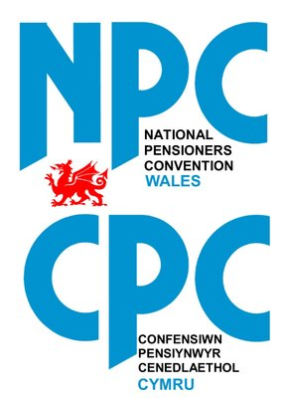
COVID-19 vaccination programme

Until recently, it seemed that this global health crisis would never end, but now we have had the hopeful news of vaccines that could see a return to near normal as soon as next spring.

That will only be possible if everyone takes the opportunity to be vaccinated against COVID-19.

NPC Wales is aware that there are some concerns about the new vaccines – we want to reassure our members and friends that any vaccine they receive will be safe and effective.

Any potential COVID-19 vaccine will undergo all the trials and testing that would normally be undertaken to ensure that they are safe – no corners have been cut and no risks to public safety have been taken. Vaccines will only be approved if they are deemed safe and effective, as with any other drug or vaccine available in this country.

It may seem that the vaccines have been developed extremely quickly. On the contrary, the ‘normal’ timeline for development of any new drug or vaccine is drawn out because of delays caused by funding applications, difficulties finding sufficient trial volunteers and any number of other everyday problems.

COVID-19 vaccines have been developed quickly because of the extraordinary efforts of scientists, governments and funding bodies, and the hundreds of thousands of volunteers who have taken part in trials all over the world.

COVID-19 vaccines are safe and effective and will save lives.

Please make sure you get vaccinated so that when we can all get back together again, no-one will be missing.

